CP Club 365 Days Challenge

**Programming language – C++**

**Problem Statement**

<https://www.codechef.com/problems/TSORT>

Git :- <https://github.com/Vedantbharad2603/CP_club_365_Days>

**Your Code**:

// 0x138Day of 0x365Days challenge

// VEDANT BHARAD

// 05-03-2023

#include<bits/stdc++.h>

using namespace std;

int main()

{

    int n;

    cin>>n;

    int a[n];

    for(int i=0;i<n;i++)

        cin>>a[i];

    sort(a,a+n);

    for(int i=0;i<n;i++)

        cout<<a[i]<<'\n';

    return 0;

}

**Output (Screen Shot)**:

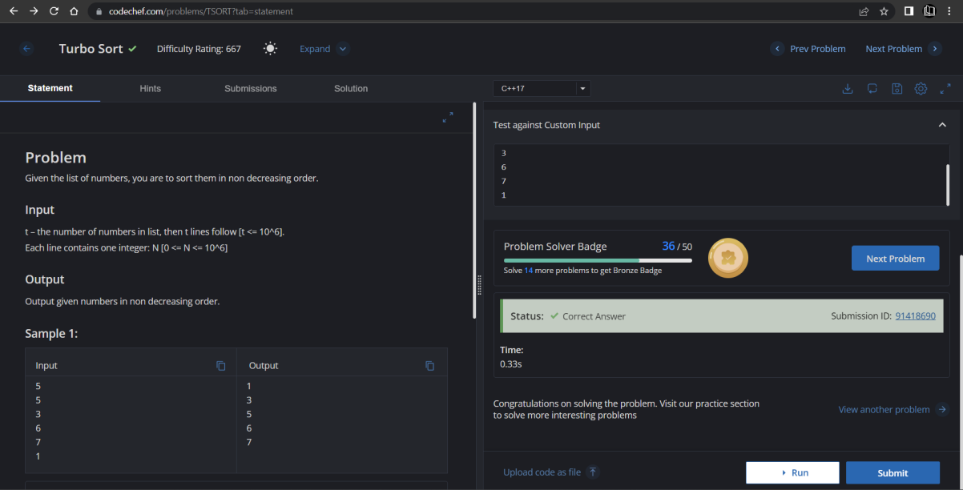

**Understanding about problem:**

* In this task I need to return Sorted form of given array.

Note: If you can't understand the problem, feel free to contact us and we'll help you. Please don't copy and paste from anywhere.

ALL THE BEST

Team CP Club